#### A. Title Page

#### B. Purpose of Document

#### C. Abstract

#### D. Table of Contents and List of Figures

### 1.0 Introduction

You should start by briefly stating the primary purpose of your project and identifying the key top-level functions that you have to implement. To generate these functions, consider the following (among other possibilities):

* interactions with the users
* functions the device performs without direct user interaction
* different modes of operations
* sequences of operations

### 2.0 Benchmarking

Identify related products and show how they map onto the functional tree that you have designed above. Estimate the performance of these related products against your evaluation criteria and compute their total value, along with estimated uncertainty bounds.

### 3.0 Concept Generation

#### 3.1 Function Concepts

Functions producing the required outcomes for the project are identified in the organizational chart in . They are categorized in two types: mechanical (in red) and electrical (in blue). Mechanical functions will act on inputs affecting the real world. Electrical functions will act on inputs affecting the virtual world and serve as a control for mechanical functions. The functional requirement of the device remaining stationary without user input (in purple) will be addressed in this document.

Figure 1 – Functional Tree Organizational Chart

|  |  |
| --- | --- |
| -------> Signal/electrical  ____> Force  .......> Material/Change in matter | input  non-critical functions  critical electrical functions  critical mechanical & electrical functions  critical mechanical functions  output |

The “global” design requirements table separated the overall device requirements into three main categories: functional, interface and ergonomics. Logically, the specific requirements for any of the devices functions should not interfere with these global requirements. In fact, if the implementation of a certain concept for a specific function, such as “device stays stationary without input”, hinders the overall product in achieving one of its global design requirements, it is considered to be a drawback of the concept itself. For that reason, the specific requirements for the function “device stays stationary without input” are directly deduced from the global design requirements table, and can also be separated into functional, interface and ergonomics groups:

**Functional:**

* Concept must prevent the cutting tool from falling towards the work piece when the robot lacks input
* When an input is present into the robot, concept must still allow the robot to fulfill the core functional requirement of providing a 3D haptic interface.

**Interface:**

* Concept must be capable of being sterilized without deteriorating of its components or hindering any of its capabilities
* Any un-sterilizable components of the concept must be completely sealed and contained in a sterilizable encasement

**Ergonomics:**

* Concept must be light-weight, weighing less than 3 lbs (considering the whole robot weight should be less than 10 lbs)
* Concept must have a size less than 25% of the link or robot arm it will be implemented on.
* Concept must add a resistance to user-directed movement less than a virtual weight of .5 kg (considering the virtual weight of the whole system should be less than 1 kg)

Evaluation Criteria for “Device stays stationary without input”:

Similar to the requirements mentioned above, the evaluation criteria for “device stays stationary without input” can also be directly deduced from the global evaluation criteria for the device as a whole. It can be seen from the user satisfaction graphs generated previously that a sharp increase in user satisfaction occurs with the decrease of total device weight, virtual weight, and size. In terms of the specific function “device stays stationary without input”, this effect is almost identical to a decrease of concept added weight, concept added virtual weight/resistance, and concept added size. Thus these portions of the concept design are considered to have high impact on the success of the concept. The most prominent portion of the concept that has a lower level of impact is the sterilizability of the components of the concept. This is still an important global requirement, but for the purpose of this specific function it is less important. Finally, there are no detailed evaluation criteria for the core functional requirement of the concept (prevent the cutting tool from falling towards the work piece when the robot lacks input), simply because a concept which doesn’t fulfill this requirement will not even pass the “go no-go” test and winnowing process to be evaluated with a detailed evaluation criteria. However, features of the concepts, such as feasibility, simplicity, and cost, are considered to be crucial in the evaluation process.

The following is a breakdown of the evaluation criteria chosen for the function “Device stays stationary without input” and their relative importance.

Table 1 – Table describing the relative importance of design criterion used to evaluate Device stays stationary without input function

|  |  |
| --- | --- |
| Criterion | Relative Importance |
| Weight addition | 25% |
| Virtual weight addition | 20% |
| Size amplification | 20% |
| Feasibility/simplicity | 15% |
| Sterilizability | 15% |
| Cost (predicted) | 5% |

Figure 2 – Chart highlighting the relative importance of design criterion used to evaluate Device stays stationary without input function

#### 3.2 Complete Concepts

Concept generation efforts have focused on developing methods to keep the tool in one position unless there is input from the user. This is the only function of the critical functions identified in that has not been implemented in previous prototypes and has serious implications on both the user and safety, and will have a the largest impact on the overall as a result. Five concepts generated are included below in Table 2. For complete analysis of each concept see APPENDIX C: Concept Generation.

Table 2 – Table of concepts generated for tool stays stationary without user input function

|  |  |  |
| --- | --- | --- |
| Type | Diagram | Description |
| Spring | D:\Dave\Dave's School\Current Semester\Praxim\Conc Alt\detail spring concept.bmp  Figure 3 – Diagram of spring constant | This concept uses energy stored in springs to counter the force due to gravity. This concept can be implemented in two ways: Using a single spring for each joint or a combination of springs on each joint. |
| Friction | C:\Users\davychiu\Desktop\2009-11-05\Image0001.JPG  Figure 4 – Diagram of friction concept | In this concept, the joints in the linkages have materials chosen with a coefficient of friction that produces a friction force to prevent the device from falling under its own weight. |
| Damper | C:\Users\davychiu\Desktop\2009-11-05\Image0001.JPG  Figure 5 – Diagram of damper concept | Hydraulic dampers are attached to the linkages to resist the force of gravity by damping the pivotal motion around the joint. |
| Motor | Motor.jpg  Figure 6 – Diagram of motor concept | The idea is to sense the link’s free-falling movement when the user removes their hand from the robot arm, or, equivalently, sense a removal of the users hand from holding the robot arm. In that instance, a motor is turned on to provide torque at the appropriate joint against that free-falling motion, and the torque is transferred to the joint using a clutch or brake mechanism. |
| Counter weight | Counterweight.jpg  Figure 7 – Diagram of counter weight concept | This concept incorporates the use of counterweights on the moving robot arms. Both rotary and linear links can utilize such a concept, with a few slight differences between the two. The idea with a counterweight is to constantly provide a countering force, similar to that of the robot arm and the cutting tool, which immediately jumps into action when the input from the surgeon is removed. |

### 4.0 Concept Selection

#### 4.1 Winnowing

The first stage in the concept evaluation is to remove concepts that are obviously not worth pursuing. This next section will consider each concept and whether that concept should be pursued further, possibly be combined with another concept, or no longer be considered.

High Friction Joints:

This concept has a serious flaw in that it requires the user to overcome the force of gravity as well as the force of friction in the joint in order to move the device away from the surface. For this reason the friction joint concept will no longer be considered.

Dampers:

This concept would not be able to achieve the desired outcome on its own; however, it does have the potential to be added to another concept in order to accomplish the required outcome. For instance dampers can be included in the spring based design to reduce unwanted oscillation and help control the speed of the tool when released by the user. The damper concept will not be further pursued on its own, but it will be considered for future improvements to other concepts.

Counter Weight:

The counter weight concept makes it very difficult to achieve the goal of minimizing the total weight of the device. Although it may appear that this concept will not allow for all requirements to be met, it will still be considered in the later stages of concept evaluation.

Motors:

The primary concern for the motor concept is the complexity of its implementation; however, in order to properly evaluate our ability to successfully implement this option more information is still required. For this reason the motor concept will still be considered in later stages of concept evaluation.

Springs:

This concept is the early favorite and will be developed further. Some of the advantages to the spring concept are as follows:

* Relatively light weight
* Highly adjustable
* Predictable

A possible disadvantage to this concept is that it could require the user to overcome the force of the spring to move closer to the surface (for the datum setup).

#### 4.2 Weighted Decision Matrix

A weighted decision matrix has been used to evaluate the three remaining concepts using the function requirements described in Section 3. The scores assigned to each concept and a description of the reasoning is included in Table 3. The description compares the concept to the current prototype design, and the following scores have been given to this device: Weight Addition (10, 250); Force required to reposition (4, 20); Size Amplification (10, 200); Feasibility/Simplicity (0,0); Sterilizability (10,150); Cost (10, 50) for a total score of 670.

Table – Weighted decision matrix comparing the performance of the counterweight, motor and spring concepts with respect to the device staying stationary without input function

|  |  |  |  |  |  |  |  |  |  |  |  |
| --- | --- | --- | --- | --- | --- | --- | --- | --- | --- | --- | --- |
|  | **wt.** | **Counterweight** | | | **Motor** | | | | **Spring** | | |
| **Score Weighted Score**  **(/10)** | | | **Score Weighted Score**  **(/10)** | | | | **Score Weighted Score**  **(/10)** | | |
| Weight Addition | **25** | 1 | 25 | Additional linkages are likely to double weight of device as the linkages make up a significant portion of overall weight and the mass of the counterweight will increase to reduce size in order to meet size requirements | 4 | 100 | The overall weight of the device must be reduced in final design and the weight of an additional motor will a significant impact on the overall weight | 6 | | 150 | The weight of the torsional springs at the joints is likely to vary with the weight of the linkages, but stiff materials can be used to reduce the weight. Use of dampers will increase the weight |
| Force required to reposition | **20** | 5 | 100 | User will have to overcome additional inertia due to counter weight. Forces can be minimized by reducing the total device weight | 4 | 200 | Concept will not change the force required to reposition tool, but the user will still need to resist gravity when motor system is not active | | 8 | 160 | User will experience additional forces as the spring is compressed or extended. These forces will always oppose the direction of movement and may improve feel as a result. The force experience can be minimized by reducing the total weight of the device |
| Size Amplification | **20** | 2 | 40 | Additional linkages will greatly increase the size | 4 | 80 | Two additional motors will have impact on size | | 7 | 140 | Spring size requirements are dependent on overall weight of device, but likely to have minimal total impact on size |
| Feasibility/ Simplicity | **15** | 10 | 150 | Concept is completely passive and can be fine tuned to increase to accept a variety of tools | 1 | 15 | Complicated programming is required to recognize when device has been released and to engage clutch. Motor must also be positioned at pivots and may interfere with encoder placement | | 7 | 105 | Concept is completely passive but mechanism to allow fine tuning to allow multiple tools will add complexity |
| Sterilizability | **15** | 8 | 120 | Additional linkages to do not reduce ease of sterilization, but the additional size may limit the number of acceptable autoclaves | 3 | 45 | Motors increase the complexity of sterilization | | 6 | 90 | Springs must be able to with stand heat requirements of autoclave, but should have minimal overall affect |
| Cost (Predicted) | **7** | 10 | 70 | All additional components are passive and linkages make up only a small portion of the overall cost | 2 | 10 | Motors and controllers currently make up a large portion of overall | | 5 | 50 | To meet design requirements springs may have significant impact on overall cost |
| Total |  | **505** | |  | **450** | |  | | **695** | |  |

### 5.0 Concept Validation

Regardless of the concept chosen it needs to be validated before it can be implemented in the final design. The following section will explore how the chosen concept(s) will be validated.

The best way to validate a concept would be to develop a quantitative experiment to measure the performance of the concept. The function that these concepts have been developed for primarily has a qualitative component to it (does the device move without input?); however, the overall performance of the concept can also be measured quantitatively (How much force is required to move the device?). So the experiment used to validate a concept should consist of two parts. The first part to test whether the device remains stationary without input in multiple different orientations and the second part to measure the force required to move the device to predetermined orientations.

In order to simplify the experiment , only two degree of freedom motion needs to be considered (the linear slide is parallel with the ground, so it does not need to be considered). Even though this concept could be proven using just one link, both should be considered to ensure that there are no unwanted coupling effects between the two links.

Other validation criteria should include the total weight of the concept and the concept's ability to be sterilized.

### 6.0 Conclusions and Recommendations

Review of the final concepts suggest that the spring concept described in section 2 is likely to meet the design requirements for the device stays stationary without input function and cause the fewest complications to the current device design. The design is not completely understood and prototypes are required to ensure that the concept delivers the desired results without unforeseen implications. Specifically the interaction between the springs at the two pivots and the resulting tool orientation is not completely understood.

### 7.0 References and Appendices

# APPENDIX A: Benchmarking

**MAKOplasty benchmark:**

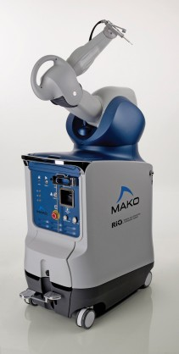

What is MAKOplasty?

MAKOplasty is a partial knee replacement procedure designed to provide quicker recovery and better surgical results for patients with joint degeneration in only one part of the knee.

How does MAKOplasty work?

The MAKOplasty procedure is minimally invasive. It uses the MAKO Tactile Guidance System (TGS) which offers precision that cannot be duplicated manually.

The TGS is impressive, featuring a surgeon-interactive robotic arm and visualization technology that allows the surgeon to create a plan for the surgery. During the MAKOplasty procedure, the TGS creates a three-dimensional, virtual view of the bone surface. It then takes that image and correlates it with the pre-programmed surgical plan.

The robotic arm is used to manipulate cutting tools inside the knee. The robotic arm feels weightless while the surgeon is cutting but changes how it feels when surgeons get close to a surgical boundary.

Robotic Arm Interactive Orthopedic System (RIO®)

The RIO® Robotic Arm Interactive Orthopedic System features three dimensional pre-surgical planning. During surgery, the RIO® provides the surgeon with real-time visual, tactile and auditory feedback to facilitate optimal joint resurfacing and implant positioning. It is this optimal placement that can result in more natural knee motion following surgery.

*RIO® Features:*

* Accurately plan implant size, orientation and alignment utilizing CT-derived 3-D modeling
* Enabling the pre-resection capture of patient-specific kinematic tracking through full flexion and extension
* Real-time intra-operative adjustments for correct knee kinematics and soft-tissue balance
* Minimally invasive and bone sparing, with minimal tissue trauma for faster recovery

**Functions:**

User Interaction

- installation/mounting - The robotic arm acts from a distance and the device is not mounted onto the patient’s body. A minimally invasive opening is made at the knee and the device operates into it.

- Model input - CT-generated pre-operative planning is available on the computer and software available (comes with the robot). The surgeon uploads the CT-scan there, plans the surgery there, and even works on the re-surfacing task while looking at the screen, only looking at the actual knee to verify the correctness of the computer.

- User connection – The surgeon operates the robot arm exactly like the haptic interface which we looked at in the CEME lab. The robot provides hard surface feedback of the desired knee shape for the implant.

- Tool connection – The burring tool is directly connected to the end of the probe the surgeon is holding. This can be interchanged for other tools as needed.

- Device motion – Full range 3-D motion is allowable by the device. When not used (the surgeon’s hand are not holding the probe), the device robot arm holds its own weight.

- on/off functionality – yes

- Sterilization – The probe and burring tool bit are metal (most likely titanium) and are small enough to be sterilized. The robot arm is not in contact with the patient, but either way, it can be covered with sterile coverings.

- Maintenance – no information about this is available.

- Positioning calibration - It seems like the calibration is done be touching designated points on the surface of the bone to be cut, so that the robot is aware of the robot arm position.

- Positioning awareness/updating – The position is constantly updated and displayed on the screen for the surgeon’s viewing.

AUTONOMOUS

- Provides tool-position constraint – Yes. It provides a hard-surface constraint based on the surface the surgeon wants to shape out, and it also gives a leeway of .5 mm of “soft bone” so that the tool does not “bounce” on the hard surface constraint. Thus, the movement of the surgeons hand is smoothened and synchronized.

- Monitoring/awareness of tool position - Yes. The position is constantly updated and displayed on the screen for the surgeon’s viewing.

- How allows 3D movement (3 DOF) – The robot arm has two link, and two active connections (between the links and between the control system/main frame and the first link. Each of these connections “seems” to be either ball-and-sockets or U-joints, resulting in a fully unconstrained 3_d motion at the probe.

- Convert input into traceable surface – Yes. The pre-operative planning software takes CT scans, processes them, and converts the area(s) of bone replacement into traceable surfaces determined by the surgeon.

MODES OF OPERATION

-On - present

-Off - present

- Idle – not present

**Very Useful Videos on Youtube:**

# MAKO Surgical Robot- Makoplasty (warning: graphic images)

MAKOplasty® partial knee resurfacing

# Dr Stefan Kreuzer Makoplasty Partial Knee Resurfacing Houston Texas

**Benchmarking – Praxiteles**

**Overview**

Praxiteles is a 2 dimensional cutting guide for total knee replacement surgeries. A guide jig is accurately positioned by Praxiteles allowing the surgeon to make planar cuts to the bone.

**Functions**

User Interaction:

* Installation/Mounting- robot mounts on femur via a 2 pins
* Model Input- Uses Praxim's bone morphing technology
* User Connection- The surgeon cuts the bone using the cutting jig that has been positioned by Praxiteles
* Tool Connection- Tool is not attach, just guided by jigs
* Device Motion- Praxiteles has two degrees of freedom. This allows for the position of the jig to accommodate all the planar cuts required.
* On/Off Functionality- yes
* Sterilization- The drive unit can be removed during sterilization
* Maintenance- not specified
* Positioning Calibration- Not specified
* Positioning Awareness- The position of the cutting jig is tracked, but the surgeon is responsible for the cutting tool itself

Autonomous:

* Provides tool-position constraint- Constrains tool movement by positioning cutting jigs
* Monitoring/Awareness of Tool Position- Aware of jig position, but not of cutting tool position
* Method of 3D Movement- Two rotational axis allow for accurate position of cutting jig
* Conversion of Input into Traceable Surface- Input via Praxim's bone morphing technology allows for tracing of planar surfaces

**Benchmarking – Mini Bone-Attached Robotic System (MBARS)**

**Overview**

MBARS was developed to provide a computer-assisted robotic tool that will “enable less and minimally invasive surgical techniques for orthopaedic surgery” while also providing more precision during bone shaping. MBARS is attached to the operated bone and shapes the bone according to a pre-operative plan that was devised to fit the implant to the patient. MBARS is rigidly attached to the bone, which is stated as “eliminating the need to compute relative motions from individually tracked entities” and allegedly results in greater precision. This precision comes from the “one-time registration” of the robot’s location on the patient’s bone. Additionally, with computer aid, more intricate designs can be implemented.

"Robotics Institute: Mini Bone-Attached Robotic System." *The Robotics Institute*. Web. 26 Oct. 2009. <http://www.ri.cmu.edu/research_project_detail.html?project_id=587&menu_id=261>.

**Functions**

User Interaction:

* Installation/Mounting- robot mounts on femur, attached by what appears (by photographic evidence only) to be 3 long threaded rods
* Model Input- not sure; merely states that the robot contains a library of patellofemoral implant models
* User Connection- device is not user operated; cutting is completely automated, like a CNC machine
* Tool Connection- not specified
* Device Motion- controlled by six separate microcontrollers connected to their own actuator; once an applicable bone model is selected, the device plans a ‘path’ to cut along, and the microcontrollers and actuators are responsible for movement. Movement can be tracked using a notebook computer
* On/Off Functionality- yes
* Sterilization- not specified
* Maintenance- not specified
* Positioning Calibration- surgeon pilots robot equipped with a force sensor along patellar tracking line on the femur—robot then automatically traces the surface of the bone with its force sensor to build a model of the articular surface
* Positioning Awareness- tracked/assumed with microcontroller/actuator pairs

Autonomous:

* Provides tool-position constraint- unclear from photos/information provided how the tool is constrained, or even what the tool looks like
* Monitoring/Awareness of Tool Position- does not appear to monitor positioning save for the calibration at the beginning of the procedure
  + What if patient moves during operation?
* Method of 3D Movement- six separate actuator/microcontroller pairs located circularly around the tool (see photo)
* Conversion of Input into Traceable Surface- there is no input, other than the calibration tracing—the device uses this path to select an appropriate model for cutting/shaping from its library

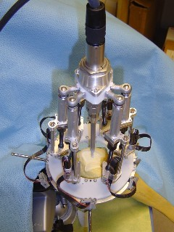

Modes of Operation

* On- yes
* Off- yes
* Idle- not specified

"Mini Bone-Attached Robot System | Sensor Based Planning Laboratory." *SCHOOL OF COMPUTER SCIENCE, Carnegie Mellon*. Web. 27 Oct. 2009. <http://www.cs.cmu.edu/~biorobotics//mbars/>

**PiGalileo benchmark:**

What is PiGalileo?

PiGalileo is a navigation system with a computer assisted cutting guide.

How does PiGalileo work?

PiGalileo works by computing the necessary cuts and alignments from the data inputted captured from an infra-red navigation camera into the navigation system using optical alignment tools. The computer then controls a 5-in-1 cutting block which a surgeon inserts a saw to make cuts to the bone. A ligament balancer apparatus is used to align the implant to ensure equally distributed loads. The surgeon is in control the entire time of the surgery (no active components).

**Functions:**

User Interaction

- installation/mounting – The computer-guided cutting block is mounted onto the bone using pins.

- Model input – This is an imageless system. Reference points captured from the infra-red cameras are projected onto generic bone models.

- User connection – The surgeon uses the “robot” as a cutting guide. It is similar to Praxiteles.

- Tool connection – The “robot” only positions a 5-in-1 universal cutting block. The surgeon inserts a saw through slots in the block.

- Device motion – The device allows only planar cuts restricted by the cutting block.

- on/off functionality – yes

- Sterilization – From pictures of the device being used in surgery, it is in direct contact with the patient and is not covered. All connections appear to be sealed.

- Maintenance – no information about this is available.

- Positioning calibration – The system is calibrated by palpating anatomical landmarks using the optical apparatus.

- Positioning awareness/updating – no information available.

AUTONOMOUS

- Provides tool-position constraint – Yes. The slots in the cutting block restrict the saw blade. The positioning robot can shift in 0.5mm steps.

- Monitoring/awareness of tool position - Yes. The position is constantly updated and displayed on the screen for the surgeon’s viewing.

- How allows 3D movement (3 DOF) – The cutting block positioning robot has two joints that allows it to move the block in only two degrees of freedom.

- Convert input into traceable surface – No. The input is only used to position the cutting block.

MODES OF OPERATION

-On - present

-Off - present

- Idle – not present

# MECH 459 - Three-Dimensional Haptic Emulation of Hard Surfaces with Applications to Orthopaedic Surgery

The device built for the 2008-2009 MECH 459 course in connection with Praxim is the predecessor to the current prototype development. The device aims to use reduce the amount of bone removed during orthopaedic surgery of the knee.

## How does Praxim 3D Haptic Hard Surface emulation work?

The device utilizes the Dynamic Physical Constraint mechanism developed by Nikolai Hungr in three-dimensions to implement a desired haptic hard surface without constraining motion away from this surface.

The hard surface is implemented passively by a stopper positioned between two linkages. The position of the stopper is controlled constantly by a systems consisting of a motor, a controllers and two encoders and positioned according to the current location of the input at the end of the second linkage. The user controls the input by holding onto a tool – drill – connected at the end of the second linkage and will not sense any active input from the device away from the surface.

## Functions

The following section will discuss the performance of the Praxim 3D Haptic Hard Surface emulator with respect to the functions identified for the current device.

### User Interactions

* Installation and mounting
  + This prototype does not have any mechanism to connect to a patient. In its current form the device could be placed next to the operating table and the patient’s knee would require additional contraining.
* Model Input
  + Surfaces generated by the device are coded into the controller and based on functions entered by the user. The user can select from three surfaces at the controls interface using a combination of four buttons.
* Tool Connection
  + Tools are connected at the end of the second linkage by a hole. There are no means to secure tools in this position or to implement different sized tools.
* Device motion
  + The device allows for complete motion away from the hard surface with three degrees of freedom. The device however cannot support its own weight and when user releases control the device will move due to gravity.
* On/Off Functionality
  + The device must be connected and disconnected from the power source in order to operate.
* Sterilization
  + There is no means to sterilize the device in its current form . A sterilized sheet could be used to cover the majority of the device but the motor will likely be exposed and has no over.
* Maintenance
  + N/A
* Positioning calibration
  + Any orientation or calibration of the position of the surface must be done at these functions and therefore cannot be easily be completed with respect to a patient’s knee.
* Positioning awareness
  + The position of the user input is constantly updated and the dynamic physical constraint is positioned accordingly, however the user has no means to determine whether these updates are taking place or how accurate they are.

### Autonomous

* Provides tool/position constraint
  + A hard surface is generated based on the series of functions mapping out the haptic surface. This surface is fixed and does not allow for any leeway and if approached at with some force will cause the mechanism to rebound in the opposite direction.
* Monitoring/awareness of too position
  + The tool position is constantly updated and the dynamic physical constraint is position accordingly.
* Three-dimensional movement
  + The device provides the user with three degrees of freedom, all translational – no rotational motion. There is only one active joint which allows for very smooth positioning and control away from haptic surface – motion is completely passive away from the haptic surface.
* Convert input into traceable surface
  + Currently there is no means to implement patient specific surfaces.

### Modes of operation

* On
  + The device is active and the physical constrain position is updated constantly based on desired haptic surface input. A red light indicates which shape has been selected.
* Off
  + The system is completely inactive.
* Idle
  + Before the desired haptic surface has been selected the device will remain completely passive where lights on the controller display the available shape options.

## 

APPENDIX B: Requirements for “Device stays stationary without input”:

The “global” design requirements table separated the overall device requirements into three main categories: functional, interface and ergonomics. Logically, the specific requirements for any of the devices functions should not interfere with these global requirements. In fact, if the implementation of a certain concept for a specific function, such as “device stays stationary without input”, hinders the overall product in achieving one of its global design requirements, it is considered to be a drawback of the concept itself. For that reason, the specific requirements for the function “device stays stationary without input” are directly deduced from the global design requirements table, and can also be separated into functional, interface and ergonomics groups:

**Functional:**

* Concept must prevent the cutting tool from falling towards the work piece when the robot lacks input
* When an input is present into the robot, concept must still allow the robot to fulfill the core functional requirement of providing a 3D haptic interface.

**Interface:**

* Concept must be capable of being sterilized without deteriorating of its components or hindering any of its capabilities
* Any un-sterilizable components of the concept must be completely sealed and contained in a sterilizable encasement

**Ergonomics:**

* Concept must be light-weight, weighing less than 3 lbs (considering the whole robot weight should be less than 10 lbs)
* Concept must have a size less than 25% of the link or robot arm it will be implemented on.
* Concept must add a resistance to user-directed movement less than a virtual weight of .5 kg (considering the virtual weight of the whole system should be less than 1 kg)

Evaluation Criteria for “Device stays stationary without input”:

Similar to the requirements mentioned above, the evaluation criteria for “device stays stationary without input” can also be directly deduced from the global evaluation criteria for the device as a whole. It can be seen from the user satisfaction graphs generated previously that a sharp increase in user satisfaction occurs with the decrease of total device weight, virtual weight, and size. In terms of the specific function “device stays stationary without input”, this effect is almost identical to a decrease of concept added weight, concept added virtual weight/resistance, and concept added size. Thus these portions of the concept design are considered to have high impact on the success of the concept. The most prominent portion of the concept that has a lower level of impact is the sterilizability of the components of the concept. This is still an important global requirement, but for the purpose of this specific function it is less important. Finally, there are no detailed evaluation criteria for the core functional requirement of the concept (prevent the cutting tool from falling towards the work piece when the robot lacks input), simply because a concept which doesn’t fulfill this requirement will not even pass the “go no-go” test and winnowing process to be evaluated with a detailed evaluation criteria. However, features of the concepts, such as feasibility, simplicity, and cost, are considered to be crucial in the evaluation process.

The following is a breakdown of the evaluation criteria chosen for the function “Device stays stationary without input” and their relative importance.

Weight addition 25%

Virtual weight addition 20%

Size amplification 20%

Feasibility/simplicity 15%

Sterilizability 15%

Cost (predicted) 5%

# APPENDIX C: Concept Generation

Motor Concept Explanation

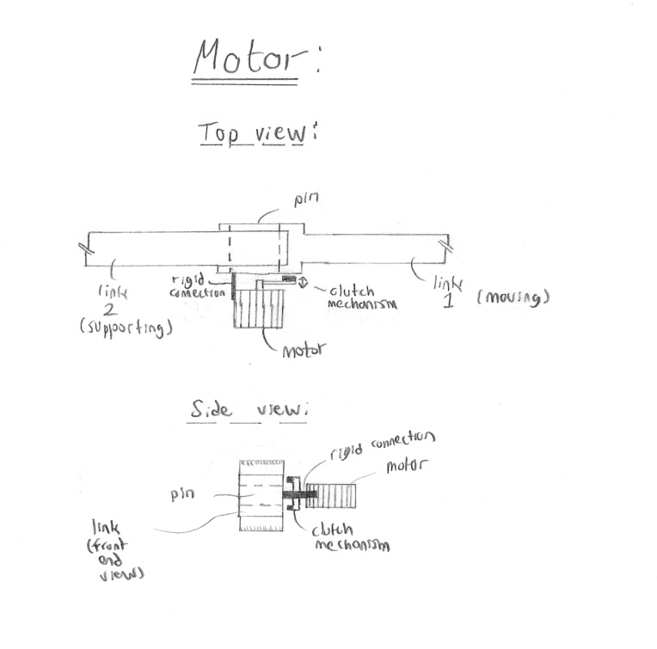

Another concept which has been generated to serve the function of the device staying stationary without input incorporates an active motor and engagement mechanism. The idea is to sense the link’s free-falling movement when the user removes their hand from the robot arm, or, equivalently, sense a removal of the users hand from holding the robot arm. In that instance, a motor is turned on to provide torque at the appropriate joint against that free-falling motion, and the torque is transferred to the joint using a clutch or brake mechanism. The beauty of the clutch or brake actuation is that it is not permanent, but is strong enough to provide sufficient retaining force through friction.

This concept has a few advantages and disadvantages associated with it. The main advantage with this concept is that it is bi-directional, meaning that whichever way the link without an input falls, a retaining force can act against it. Another advantage of this system is its quantifiable retaining capability, which is considered to be high compared to other concepts. It is enough to realize that brakes and clutches are used in many other applications which require a lot more torque. However, disadvantages of this concept are that it is complicated and expensive. The complication comes in the choice of motor and the design of a suitable actuation mechanism, along with the design of suitable mounting methods to the robot. In addition, it is definitely not the cheapest of concepts, mainly because it involves the purchase of a motor. In addition, the mechanism as a whole, with the motor itself, will probably add significant weight to the robot. Finally, this concept is an active system, meaning that it cannot operate without power. This can be a concern in power outages or even shortages in the operating room.

Counterweight Concept Explanation

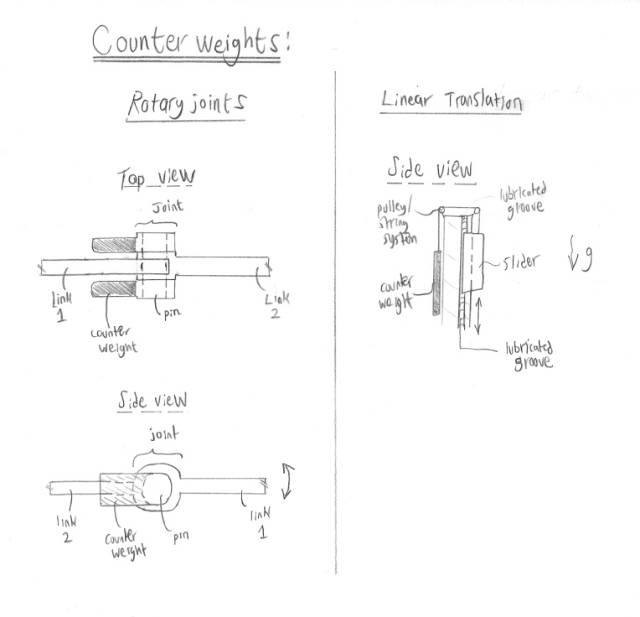

Quite a simple and intuitive solution to serve the function of the device staying stationary without input incorporates the use of counterweights on the moving robot arms. Both rotary and linear links can utilize such a concept, with a few slight differences between the two. The idea with a counterweight is to constantly provide a countering force, similar to that of the robot arm and the cutting tool, which immediately jumps into action when the input from the surgeon is removed. The system is passive, so it doesn’t require any power input. Also, the system is adjustable to different robot arms and different sizes and weight of tools

The main advantage of the counterweight system is that it is simple and inexpensive. The actual counterweight can be any high-density material and can almost be oriented in any position, so long as it provides a consistent and sufficient countering force when needed. The disadvantage of this system is that the weight of the robot arm is essentially doubled with the addition of the counterweight, thus making the overall robot weigh considerably more. In addition, “sterilizability” of this system is predicted to be a more difficult task than in other systems. This is due to the introduction of large areas of unsterile surfaces. Finally, a prominent disadvantage of this system is that the “virtual” weight of the robot arm is substantially increased. When working with the robot, the surgeon must apply a force to overcome the counterweight in addition to the force needed to do the initial cutting work.

**Spring Concept:**

This concept uses energy stored in springs to counter the force due to gravity. This concept can be implemented in two ways: Using a single spring for each joint, or a combinations of springs on each joint.

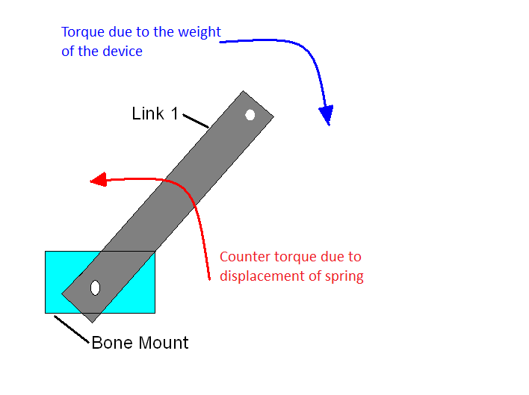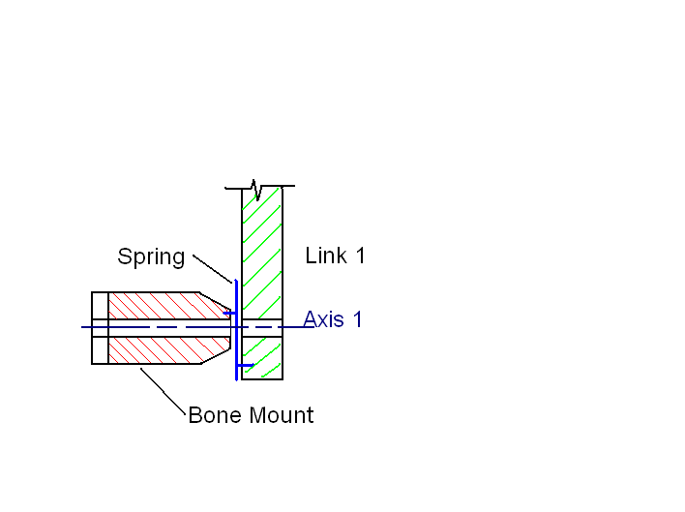

Having a single spring on each joint would be able to exactly counter gravity at a datum; however, when the device is closer to the surface than the datum, the device will return to the datum when released.

The other option for this concept is to have a combination of springs on each joint that could be adjusted to exactly counter gravity at any point in the link's rotation [1]. With this setup the device would remain stationary regardless of its position if the user released it. This setup also has the potential to be adjusted in such a way that it too could return to a datum if desired.

Advantages / Disadvantages

Some of the advantages to the spring concept are as follows:

* Relatively light weight
* Highly adjustable
* Predictable

A possible disadvantage to this concept is that it could require the user to overcome the force of the spring to move closer to the surface (for the datum setup)

**Work Cited:**

1. Barents et al, *Spring- to-Spring as Energy-Free Adjustment Method in Gravity Equilibrators*, 2009

# Friction Concept

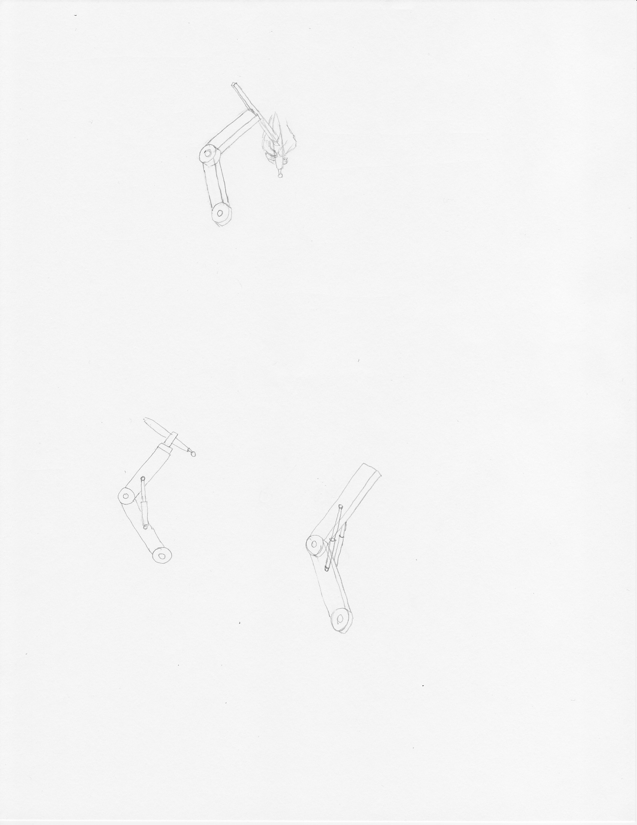

In this concept, the joints in the linkages have materials chosen with a coefficient of friction that produces a friction force to prevent the device from falling under its own weight.

There are obvious disadvantages with this design. As a consequence of maintaining the position of the device, it imposes additional virtual weight that the user must overcome when trying to reposition it. The momentum from the force required to put it into motion can result in moving past the desired location. This may not be acceptable in a surgical setting. In addition, it is unidirectional, meaning that it only reduces the virtual weight moving down. When moving up, the user now must overcome the weight of the device and additional friction. Also, using different tools with different weights will require the joints to be readjusted.

However, it has advantages in that it is very simple, easy to implement and has no issues with sterilization. It is also a passive solution, which means it is unpowered and will remain in position with no input.

# Damper Concept



Hydraulic dampers are attached to the linkages to resist the force of gravity by damping the pivotal motion around the joint.

The most concerning disadvantage with this concept is that sterilization is not easily achievable due to the shaft of the hydraulic damper being exposed in a surgical environment. Similar to the high friction joint concept, this also creates additional virtual weight needed for repositioning of the device. Since moving the device up requires the user to overcome both the weight and the damper, it is also unidirectional.

An advantage this concept has is that it can be implemented with either passive or active controls. The actively controlled dampers would use sensors to adjust them to reduce virtual weight. Relative to the complexity of the other concepts, this concept would be low complexity for passive and high complexity for active.